Birth Data Report

Allison Young

September 22, 2018

### Printed Summary of File

textsummary(fname,births)

## [1] " smoking.csv : This file has 869 rows, and 12 columns"  
## [1] "The varible names are id, date, gestation, bwt.oz, parity, mrace, mage, med, mht, mpregwt, inc, smoke"

### I. Explored Data

Explored diminsions of the file and summaries of variables.

## [1] " file : This file has 869 rows, and 12 columns"  
## 'data.frame': 869 obs. of 12 variables:  
## $ id : int 4604 7435 7722 2026 3553 3491 6757 6153 8187 8403 ...  
## $ date : int 1598 1527 1563 1503 1638 1705 1444 1405 1669 1669 ...  
## $ gestation: int 148 181 204 225 233 234 234 235 236 241 ...  
## $ bwt.oz : int 116 110 55 132 105 85 97 129 63 128 ...  
## $ parity : int 7 7 11 4 4 7 0 3 0 0 ...  
## $ mrace : int 7 7 7 7 7 7 6 7 5 7 ...  
## $ mage : int 28 27 35 28 34 33 26 24 24 17 ...  
## $ med : int 1 1 3 2 3 1 5 4 5 1 ...  
## $ mht : int 66 64 65 67 61 67 65 66 58 64 ...  
## $ mpregwt : int 135 133 140 148 130 130 112 135 99 126 ...  
## $ inc : int 2 1 6 3 3 2 6 1 7 2 ...  
## $ smoke : int 0 0 0 0 0 0 0 0 0 0 ...  
## NULL  
## id date gestation bwt.oz   
## Min. : 15 Min. :1350 Min. :148.0 Min. : 55.0   
## 1st Qu.:5477 1st Qu.:1444 1st Qu.:272.0 1st Qu.:108.0   
## Median :6734 Median :1540 Median :279.0 Median :119.0   
## Mean :6032 Mean :1536 Mean :278.5 Mean :118.4   
## 3rd Qu.:7587 3rd Qu.:1627 3rd Qu.:286.0 3rd Qu.:129.0   
## Max. :9263 Max. :1714 Max. :338.0 Max. :174.0   
## parity mrace mage med   
## Min. : 0.000 Min. :0.000 Min. :15.00 Min. :0.000   
## 1st Qu.: 1.000 1st Qu.:0.000 1st Qu.:23.00 1st Qu.:2.000   
## Median : 2.000 Median :2.000 Median :26.00 Median :2.000   
## Mean : 1.953 Mean :2.995 Mean :27.29 Mean :2.932   
## 3rd Qu.: 3.000 3rd Qu.:7.000 3rd Qu.:31.00 3rd Qu.:4.000   
## Max. :11.000 Max. :9.000 Max. :45.00 Max. :7.000   
## mht mpregwt inc smoke   
## Min. :53.00 Min. : 87.0 Min. :0.000 Min. :0.0000   
## 1st Qu.:62.00 1st Qu.:113.0 1st Qu.:2.000 1st Qu.:0.0000   
## Median :64.00 Median :125.0 Median :3.000 Median :0.0000   
## Mean :64.07 Mean :128.5 Mean :3.681 Mean :0.4638   
## 3rd Qu.:66.00 3rd Qu.:140.0 3rd Qu.:5.000 3rd Qu.:1.0000   
## Max. :72.00 Max. :220.0 Max. :9.000 Max. :1.0000

### Predictor Variable Transformations and Labeling

-Changed bwt.oz to bwt, mean centered date variable and re-visited converting date variables to strings for interpretation. -Created a new column, “mracetxt” to hold the new race variable names, “White” (categories 0-5), “Mexican”, “Black”, “Asian”, and “Mix”. -Created new label columns for mother education and mother income. -Plotted histograms and box plots of x variables for both continuous and categorical variables.

## II. Explored Relationships

Outcome Variable: Birthweight (bwt)

First, I mapped a series of plots between birthweights and predictor variables, and looked at the relationship between birthweight and smoking. When looking at birthweight and smoking by race, there appeared to potentially be an interaction by race as well as a clear difference between some races, such as between black and white babies.

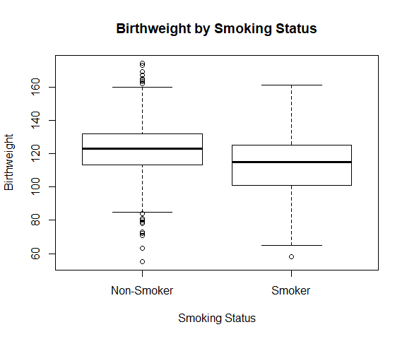

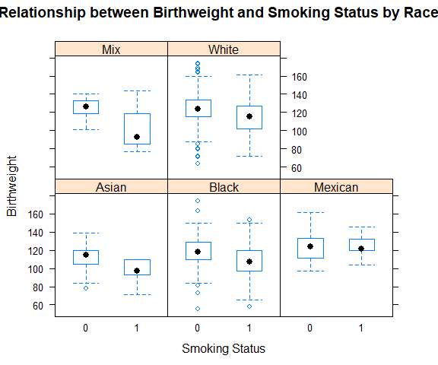

## III. Initial Modeling

After considering inital plots and a few initial models, I settled on a model to plot out, and check residuals for.

### Model 1 (with interaction)

**Baseline Predictor Factors:** Smoker= Non Smoker, Race= White Mother, Mother Education = HS Grad Only, Income = $10,000 - $12,499; **Model Variables:** Mother Age, Mother Height, Mother Pregnant Weight, Parity, Date of Birth  
**Interaction:** Mother Race(As Factor, White) * Smoke(As Factor, Smoker)(see end of document for model output for Model 1, as this was the model I settled on)

Mod1 <- lm(bwt~mageCent + mhtCent + mpregwtCent + dateCent+ parityCent + relevel(as.factor(medtxt), ref = "HS Grad Only")+ relevel(as.factor(inctxt), ref="10000-12499") + relevel(as.factor(smoke), ref="0") * relevel(as.factor(mracetxt), ref="White"), data = births)  
#summary(Mod1)

#### Model 1 Residuals by Predictor Variables

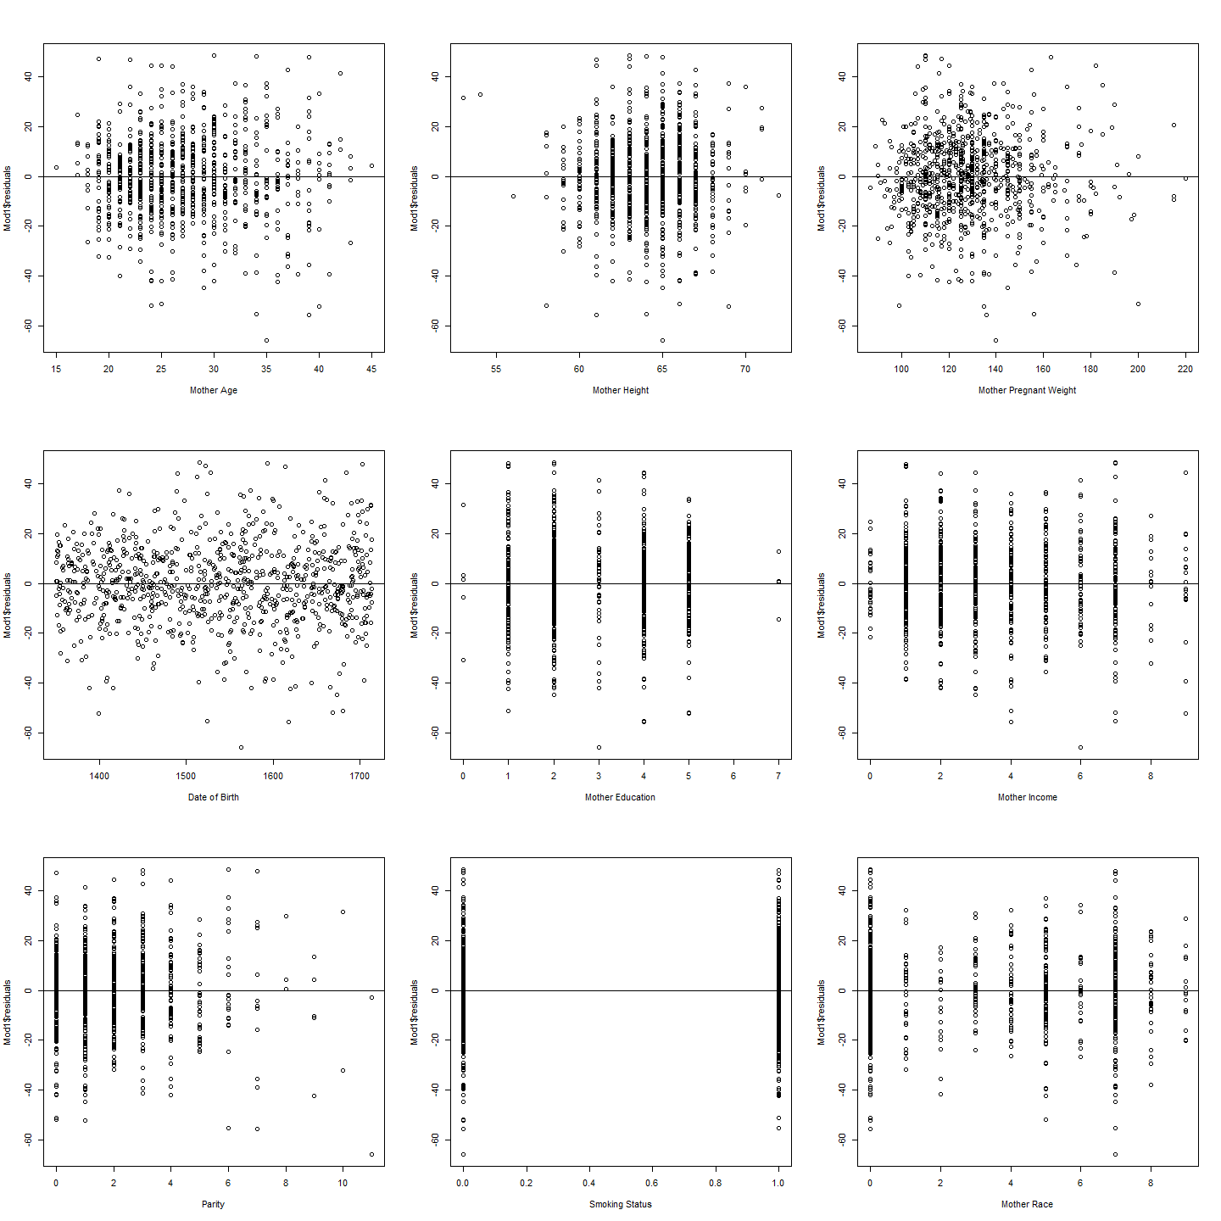The residuals for this model look pretty good.

### Model 2 (without interaction)

I also created a second model without interaction and summarized it as well.

**Baseline Predictor Factors:** Smoker= Non Smoker, Race= White Mother, Mother Education = HS Grad Only, Income = $10,000 - $12,499; **Model Variables:** Mother Age, Mother Height, Mother Pregnant Weight, Parity, Date of Birth  
**No Interaction**

Mod2 <- lm(bwt~mageCent + mhtCent + mpregwtCent + dateCent+ parityCent + relevel(as.factor(medtxt), ref = "HS Grad Only")+ relevel(as.factor(inctxt), ref="10000-12499") + relevel(as.factor(smoke), ref="0") + relevel(as.factor(mracetxt), ref="White"), data = births)  
summary(Mod2)

##   
## Call:  
## lm(formula = bwt ~ mageCent + mhtCent + mpregwtCent + dateCent +   
## parityCent + relevel(as.factor(medtxt), ref = "HS Grad Only") +   
## relevel(as.factor(inctxt), ref = "10000-12499") + relevel(as.factor(smoke),   
## ref = "0") + relevel(as.factor(mracetxt), ref = "White"),   
## data = births)  
##   
## Residuals:  
## Min 1Q Median 3Q Max   
## -66.639 -9.423 -0.108 10.078 48.796   
##   
## Coefficients:  
## Estimate  
## (Intercept) 124.980651  
## mageCent -0.035073  
## mhtCent 0.989393  
## mpregwtCent 0.106565  
## dateCent 0.013113  
## parityCent 0.765674  
## relevel(as.factor(medtxt), ref = "HS Grad Only")8th to 12th, No Grad -2.365956  
## relevel(as.factor(medtxt), ref = "HS Grad Only")College Grad -0.384007  
## relevel(as.factor(medtxt), ref = "HS Grad Only")HS Grad and Trade -1.614469  
## relevel(as.factor(medtxt), ref = "HS Grad Only")HS Grade and Some College 0.575002  
## relevel(as.factor(medtxt), ref = "HS Grad Only")Less than 8th Grade -7.574706  
## relevel(as.factor(medtxt), ref = "HS Grad Only")Trade School (HSG Unknown) -11.765009  
## relevel(as.factor(inctxt), ref = "10000-12499")12500-14999 -0.643186  
## relevel(as.factor(inctxt), ref = "10000-12499")15000-17499 -1.641822  
## relevel(as.factor(inctxt), ref = "10000-12499")17500-19999 -0.472261  
## relevel(as.factor(inctxt), ref = "10000-12499")20000-22499 -0.027176  
## relevel(as.factor(inctxt), ref = "10000-12499")22500+ -4.673728  
## relevel(as.factor(inctxt), ref = "10000-12499")2500-4999 0.980664  
## relevel(as.factor(inctxt), ref = "10000-12499")5000-7499 2.525336  
## relevel(as.factor(inctxt), ref = "10000-12499")7500-9999 -0.755775  
## relevel(as.factor(inctxt), ref = "10000-12499")Under 2500 -2.076024  
## relevel(as.factor(smoke), ref = "0")1 -9.010719  
## relevel(as.factor(mracetxt), ref = "White")Asian -7.451374  
## relevel(as.factor(mracetxt), ref = "White")Black -9.239311  
## relevel(as.factor(mracetxt), ref = "White")Mexican 3.879319  
## relevel(as.factor(mracetxt), ref = "White")Mix -3.046525  
## Std. Error  
## (Intercept) 1.928335  
## mageCent 0.133964  
## mhtCent 0.269550  
## mpregwtCent 0.032886  
## dateCent 0.005454  
## parityCent 0.399790  
## relevel(as.factor(medtxt), ref = "HS Grad Only")8th to 12th, No Grad 1.857682  
## relevel(as.factor(medtxt), ref = "HS Grad Only")College Grad 1.727372  
## relevel(as.factor(medtxt), ref = "HS Grad Only")HS Grad and Trade 2.659958  
## relevel(as.factor(medtxt), ref = "HS Grad Only")HS Grade and Some College 1.546265  
## relevel(as.factor(medtxt), ref = "HS Grad Only")Less than 8th Grade 7.687072  
## relevel(as.factor(medtxt), ref = "HS Grad Only")Trade School (HSG Unknown) 8.479716  
## relevel(as.factor(inctxt), ref = "10000-12499")12500-14999 2.373723  
## relevel(as.factor(inctxt), ref = "10000-12499")15000-17499 2.777986  
## relevel(as.factor(inctxt), ref = "10000-12499")17500-19999 2.310605  
## relevel(as.factor(inctxt), ref = "10000-12499")20000-22499 4.545115  
## relevel(as.factor(inctxt), ref = "10000-12499")22500+ 4.101645  
## relevel(as.factor(inctxt), ref = "10000-12499")2500-4999 2.184521  
## relevel(as.factor(inctxt), ref = "10000-12499")5000-7499 2.161961  
## relevel(as.factor(inctxt), ref = "10000-12499")7500-9999 2.183302  
## relevel(as.factor(inctxt), ref = "10000-12499")Under 2500 3.722298  
## relevel(as.factor(smoke), ref = "0")1 1.180416  
## relevel(as.factor(mracetxt), ref = "White")Asian 3.115701  
## relevel(as.factor(mracetxt), ref = "White")Black 1.588428  
## relevel(as.factor(mracetxt), ref = "White")Mexican 3.523412  
## relevel(as.factor(mracetxt), ref = "White")Mix 4.430314  
## t value  
## (Intercept) 64.813  
## mageCent -0.262  
## mhtCent 3.671  
## mpregwtCent 3.240  
## dateCent 2.404  
## parityCent 1.915  
## relevel(as.factor(medtxt), ref = "HS Grad Only")8th to 12th, No Grad -1.274  
## relevel(as.factor(medtxt), ref = "HS Grad Only")College Grad -0.222  
## relevel(as.factor(medtxt), ref = "HS Grad Only")HS Grad and Trade -0.607  
## relevel(as.factor(medtxt), ref = "HS Grad Only")HS Grade and Some College 0.372  
## relevel(as.factor(medtxt), ref = "HS Grad Only")Less than 8th Grade -0.985  
## relevel(as.factor(medtxt), ref = "HS Grad Only")Trade School (HSG Unknown) -1.387  
## relevel(as.factor(inctxt), ref = "10000-12499")12500-14999 -0.271  
## relevel(as.factor(inctxt), ref = "10000-12499")15000-17499 -0.591  
## relevel(as.factor(inctxt), ref = "10000-12499")17500-19999 -0.204  
## relevel(as.factor(inctxt), ref = "10000-12499")20000-22499 -0.006  
## relevel(as.factor(inctxt), ref = "10000-12499")22500+ -1.139  
## relevel(as.factor(inctxt), ref = "10000-12499")2500-4999 0.449  
## relevel(as.factor(inctxt), ref = "10000-12499")5000-7499 1.168  
## relevel(as.factor(inctxt), ref = "10000-12499")7500-9999 -0.346  
## relevel(as.factor(inctxt), ref = "10000-12499")Under 2500 -0.558  
## relevel(as.factor(smoke), ref = "0")1 -7.634  
## relevel(as.factor(mracetxt), ref = "White")Asian -2.392  
## relevel(as.factor(mracetxt), ref = "White")Black -5.817  
## relevel(as.factor(mracetxt), ref = "White")Mexican 1.101  
## relevel(as.factor(mracetxt), ref = "White")Mix -0.688  
## Pr(>|t|)  
## (Intercept) < 2e-16  
## mageCent 0.793535  
## mhtCent 0.000257  
## mpregwtCent 0.001240  
## dateCent 0.016418  
## parityCent 0.055806  
## relevel(as.factor(medtxt), ref = "HS Grad Only")8th to 12th, No Grad 0.203154  
## relevel(as.factor(medtxt), ref = "HS Grad Only")College Grad 0.824129  
## relevel(as.factor(medtxt), ref = "HS Grad Only")HS Grad and Trade 0.544046  
## relevel(as.factor(medtxt), ref = "HS Grad Only")HS Grade and Some College 0.710087  
## relevel(as.factor(medtxt), ref = "HS Grad Only")Less than 8th Grade 0.324719  
## relevel(as.factor(medtxt), ref = "HS Grad Only")Trade School (HSG Unknown) 0.165677  
## relevel(as.factor(inctxt), ref = "10000-12499")12500-14999 0.786487  
## relevel(as.factor(inctxt), ref = "10000-12499")15000-17499 0.554671  
## relevel(as.factor(inctxt), ref = "10000-12499")17500-19999 0.838099  
## relevel(as.factor(inctxt), ref = "10000-12499")20000-22499 0.995231  
## relevel(as.factor(inctxt), ref = "10000-12499")22500+ 0.254828  
## relevel(as.factor(inctxt), ref = "10000-12499")2500-4999 0.653608  
## relevel(as.factor(inctxt), ref = "10000-12499")5000-7499 0.243106  
## relevel(as.factor(inctxt), ref = "10000-12499")7500-9999 0.729308  
## relevel(as.factor(inctxt), ref = "10000-12499")Under 2500 0.577179  
## relevel(as.factor(smoke), ref = "0")1 6.18e-14  
## relevel(as.factor(mracetxt), ref = "White")Asian 0.016995  
## relevel(as.factor(mracetxt), ref = "White")Black 8.52e-09  
## relevel(as.factor(mracetxt), ref = "White")Mexican 0.271206  
## relevel(as.factor(mracetxt), ref = "White")Mix 0.491859  
##   
## (Intercept) ***  
## mageCent   
## mhtCent ***  
## mpregwtCent **   
## dateCent *   
## parityCent .   
## relevel(as.factor(medtxt), ref = "HS Grad Only")8th to 12th, No Grad   
## relevel(as.factor(medtxt), ref = "HS Grad Only")College Grad   
## relevel(as.factor(medtxt), ref = "HS Grad Only")HS Grad and Trade   
## relevel(as.factor(medtxt), ref = "HS Grad Only")HS Grade and Some College   
## relevel(as.factor(medtxt), ref = "HS Grad Only")Less than 8th Grade   
## relevel(as.factor(medtxt), ref = "HS Grad Only")Trade School (HSG Unknown)   
## relevel(as.factor(inctxt), ref = "10000-12499")12500-14999   
## relevel(as.factor(inctxt), ref = "10000-12499")15000-17499   
## relevel(as.factor(inctxt), ref = "10000-12499")17500-19999   
## relevel(as.factor(inctxt), ref = "10000-12499")20000-22499   
## relevel(as.factor(inctxt), ref = "10000-12499")22500+   
## relevel(as.factor(inctxt), ref = "10000-12499")2500-4999   
## relevel(as.factor(inctxt), ref = "10000-12499")5000-7499   
## relevel(as.factor(inctxt), ref = "10000-12499")7500-9999   
## relevel(as.factor(inctxt), ref = "10000-12499")Under 2500   
## relevel(as.factor(smoke), ref = "0")1 ***  
## relevel(as.factor(mracetxt), ref = "White")Asian *   
## relevel(as.factor(mracetxt), ref = "White")Black ***  
## relevel(as.factor(mracetxt), ref = "White")Mexican   
## relevel(as.factor(mracetxt), ref = "White")Mix   
## ---  
## Signif. codes: 0 '***' 0.001 '**' 0.01 '*' 0.05 '.' 0.1 ' ' 1  
##   
## Residual standard error: 16.71 on 843 degrees of freedom  
## Multiple R-squared: 0.1681, Adjusted R-squared: 0.1434   
## F-statistic: 6.814 on 25 and 843 DF, p-value: < 2.2e-16

##### Model 2 Residuals by Predictor Variable

Plotted Variable residuals for Model 2 are similar to those of Model 1.

## IV. Refining the Model

### Are these two models different? Nested F-test

Next, I did a comparison using ANOVA to see if the interaction I included on the first test makes a difference. Results showed that while there appears to be an interaction by race, the p value is too high to say they are signifcant ( 0.1637). [NOTE: The fact that this interaction is not significant is also evident by the large p values of the coefficient estimates for the interaction between variables of mothers race and smoking status in the first model, listed in the final interpretation of the model]

anova(Mod1,Mod2)

## Analysis of Variance Table  
##   
## Model 1: bwt ~ mageCent + mhtCent + mpregwtCent + dateCent + parityCent +   
## relevel(as.factor(medtxt), ref = "HS Grad Only") + relevel(as.factor(inctxt),   
## ref = "10000-12499") + relevel(as.factor(smoke), ref = "0") *   
## relevel(as.factor(mracetxt), ref = "White")  
## Model 2: bwt ~ mageCent + mhtCent + mpregwtCent + dateCent + parityCent +   
## relevel(as.factor(medtxt), ref = "HS Grad Only") + relevel(as.factor(inctxt),   
## ref = "10000-12499") + relevel(as.factor(smoke), ref = "0") +   
## relevel(as.factor(mracetxt), ref = "White")  
## Res.Df RSS Df Sum of Sq F Pr(>F)  
## 1 839 233460   
## 2 843 235278 -4 -1818.2 1.6336 0.1637

### Multicollinearity

I also looked at whether parity was highly correlated with mother’s age, and if so, if it could be removed from the model. Results showed that while there is a correlation (.52), it is not high enough to remove parity from the model.

cor(births$mage,births$parity)

## [1] 0.5236904

After these two additional explorations, the best R^2 I was able to achieve was 0.175. I have achieved is I feel good interpreting my selected model.

## V. Final Model Interpretation

The Final Model I selected is:

Mod1 <- lm(bwt~mageCent + mhtCent + mpregwtCent + dateCent+ parityCent + relevel(as.factor(medtxt), ref = “HS Grad Only”)+ relevel(as.factor(inctxt), ref=“10000-12499”) + relevel(as.factor(smoke), ref=“0”) * relevel(as.factor(mracetxt), ref=“White”), data = births)

### Important Predictive Factors

From my analysis, the most important predictor factors of birthweight were smoking status, the mother’s race, height, and weight, and the date of birth.

#### Mother Height Holding all other factors constant(Non-smoker,White, HS Grad Only, 10-12.5k, mean age, mean weight, mean date of birth, and mean parity), we are 95% confident that the true mean difference in birthweight for an inch increase in mother’s height is between CI[0.52, 1.58], with a point estimate of 1.05 oz.

Therefore, using this model, we can estimate that for every inch increase in the height of a mother during pregnancy, we would expect to see a 1.05 oz increase in the child’s birthweight. With a p value of 0.000119, this predictor is very highly significant (<.0005).

#### Mother Pregnant Weight

Holding all other factors constant(Non-smoker,White, HS Grad Only, 10-12.5k, mean age, mean height, mean date of birth, and mean parity), we are 95% confident that the true mean difference in birthweight for an inch increase in mother’s weight is between CI[0.04, 0.17], with a point estimate of 0.11 oz.

Therefore, using this model, we can estimate that for every pound increase in the weight of a mother during pregnancy, we would expect to see a 0.11 oz increase in the child’s birthweight. With a p value of 0.001210, this predictor is highly significant(<.005).

#### Mother Age

With a p value of 0.781, this predictor is not significant( >.05).

#### Mother Education

With p values >.05, this predictor is not significant.

#### Date of Birth

Holding all other factors constant(Non-smoker,White, HS Grad Only, 10-12.5k, mean weight, mean height, mean age, and mean parity), we are 95% confident that the true mean difference in birthweight for each additional year in date of birth, is between CI[0.73, 8.54], with a point estimate of 4.64 oz.

Therefore, using this model, we can estimate that for every year increase in the date of birth, we would expect to see a 4.64 oz increase in the child’s birthweight. With a p value of 0.019987, this predictor is significant (<.05).

#### Parity

With a p value of 0.055566, this predictor is not significant (>.05).

#### Smoking Status

Holding all other factors constant(White, HS Grad Only, 10-12.5k, mean age, mean height, mean weight, mean date of birth, and mean parity, we are 95% confident that the true mean difference in birthweight between a smoking and non-smoking mother (White) is between CI[-12.11, -6.74], with a point estimate of -9.427 oz.

Therefore, using this model, we can estimate the birthweight of a baby born to a nonsmoking Mother(White, HS Grad Only, 10-12.5k): 125.26 oz. And compare that to the estimated birthweight of a mother of the same demographics, who smokes: 115.83 oz. With a p value of 0.019987, this predictor is significant (<.05).

#### Income of Mother

With p values >.05, this predictor is not significant.

#### Race of Mother

Holding all other factors constant(Non-smoker,HS Grad Only, 10-12.5k, mean age, mean height, mean weight, mean date of birth, and mean parity), we are 95% confident that the true mean difference in birthweight between a mother who is White and mothers who are of other races is between the following: Asian CI[-12.68, 1.58] & pt est (-5.55) , Black CI[-14.40,-6.11] & pt est(-10.26), Mexican CI[-7.28,8.45] & pt est (0.58), Mix CI[-10.17,9.32] & pt est (-0.42).

Therefore, using this model, we can estimate the birthweight of a baby born to a White Mother(other demographics constant)as 125.26 oz. And compare that to the estimated birthweight of a mother of the same demographics, but of different Races: Asian 119.71 oz., Black 115.00 oz., Mexican 125.84 oz., Mix 124.84 oz. With a p-value of <.0005, this predictor is very highly significant.

#### Interaction between Smoking and Race

Finally, we can take a look at the interaction between race and smoking status as it pertains to our model. To calculate the interaction affect, we would add the difference from baseline based on smoking status + the difference from baseline based on race, and then also add a third variable, which represents the interaction for that race given smoking status.

For example, a mother who is Black and smokes, will see a difference of -17.24 oz, resulting in an estimated birthweight of 108.02 oz. (as compared to a simple sum of Black race and smoker factors, which would be -19.68). However, a mother who is Mexican and smokes, will see a difference of 5.44 oz, resulting in an estimated birthweight of 130.7.(as compared to a simple sum of Mexican race and smoker factors, which would be -8.85).

Therefore, it appears an interaction does exists because the combination of race and smoker results in a variation in estimated birthweight, as compared to the independent factors alone. However, with no p values <.05, we can not say any of these interactions are significant.

summary(Mod1)

##   
## Call:  
## lm(formula = bwt ~ mageCent + mhtCent + mpregwtCent + dateCent +   
## parityCent + relevel(as.factor(medtxt), ref = "HS Grad Only") +   
## relevel(as.factor(inctxt), ref = "10000-12499") + relevel(as.factor(smoke),   
## ref = "0") * relevel(as.factor(mracetxt), ref = "White"),   
## data = births)  
##   
## Residuals:  
## Min 1Q Median 3Q Max   
## -66.050 -9.772 -0.282 10.290 48.605   
##   
## Coefficients:  
## Estimate  
## (Intercept) 125.259982  
## mageCent -0.037103  
## mhtCent 1.046710  
## mpregwtCent 0.106746  
## dateCent 0.012706  
## parityCent 0.769129  
## relevel(as.factor(medtxt), ref = "HS Grad Only")8th to 12th, No Grad -2.742977  
## relevel(as.factor(medtxt), ref = "HS Grad Only")College Grad -0.541865  
## relevel(as.factor(medtxt), ref = "HS Grad Only")HS Grad and Trade -1.502135  
## relevel(as.factor(medtxt), ref = "HS Grad Only")HS Grade and Some College 0.431214  
## relevel(as.factor(medtxt), ref = "HS Grad Only")Less than 8th Grade -9.904488  
## relevel(as.factor(medtxt), ref = "HS Grad Only")Trade School (HSG Unknown) -11.072093  
## relevel(as.factor(inctxt), ref = "10000-12499")12500-14999 -0.565441  
## relevel(as.factor(inctxt), ref = "10000-12499")15000-17499 -1.663774  
## relevel(as.factor(inctxt), ref = "10000-12499")17500-19999 -0.514136  
## relevel(as.factor(inctxt), ref = "10000-12499")20000-22499 0.003081  
## relevel(as.factor(inctxt), ref = "10000-12499")22500+ -4.367393  
## relevel(as.factor(inctxt), ref = "10000-12499")2500-4999 0.940746  
## relevel(as.factor(inctxt), ref = "10000-12499")5000-7499 2.679089  
## relevel(as.factor(inctxt), ref = "10000-12499")7500-9999 -0.818641  
## relevel(as.factor(inctxt), ref = "10000-12499")Under 2500 -2.089540  
## relevel(as.factor(smoke), ref = "0")1 -9.426709  
## relevel(as.factor(mracetxt), ref = "White")Asian -5.549252  
## relevel(as.factor(mracetxt), ref = "White")Black -10.259062  
## relevel(as.factor(mracetxt), ref = "White")Mexican 0.584158  
## relevel(as.factor(mracetxt), ref = "White")Mix -0.423766  
## relevel(as.factor(smoke), ref = "0")1:relevel(as.factor(mracetxt), ref = "White")Asian -6.852602  
## relevel(as.factor(smoke), ref = "0")1:relevel(as.factor(mracetxt), ref = "White")Black 2.436905  
## relevel(as.factor(smoke), ref = "0")1:relevel(as.factor(mracetxt), ref = "White")Mexican 14.286891  
## relevel(as.factor(smoke), ref = "0")1:relevel(as.factor(mracetxt), ref = "White")Mix -13.461402  
## Std. Error  
## (Intercept) 1.944058  
## mageCent 0.133895  
## mhtCent 0.270661  
## mpregwtCent 0.032869  
## dateCent 0.005451  
## parityCent 0.401197  
## relevel(as.factor(medtxt), ref = "HS Grad Only")8th to 12th, No Grad 1.864105  
## relevel(as.factor(medtxt), ref = "HS Grad Only")College Grad 1.728955  
## relevel(as.factor(medtxt), ref = "HS Grad Only")HS Grad and Trade 2.658927  
## relevel(as.factor(medtxt), ref = "HS Grad Only")HS Grade and Some College 1.545697  
## relevel(as.factor(medtxt), ref = "HS Grad Only")Less than 8th Grade 7.782763  
## relevel(as.factor(medtxt), ref = "HS Grad Only")Trade School (HSG Unknown) 8.480974  
## relevel(as.factor(inctxt), ref = "10000-12499")12500-14999 2.374054  
## relevel(as.factor(inctxt), ref = "10000-12499")15000-17499 2.787096  
## relevel(as.factor(inctxt), ref = "10000-12499")17500-19999 2.318983  
## relevel(as.factor(inctxt), ref = "10000-12499")20000-22499 4.554598  
## relevel(as.factor(inctxt), ref = "10000-12499")22500+ 4.105500  
## relevel(as.factor(inctxt), ref = "10000-12499")2500-4999 2.198375  
## relevel(as.factor(inctxt), ref = "10000-12499")5000-7499 2.173077  
## relevel(as.factor(inctxt), ref = "10000-12499")7500-9999 2.189719  
## relevel(as.factor(inctxt), ref = "10000-12499")Under 2500 3.727246  
## relevel(as.factor(smoke), ref = "0")1 1.368644  
## relevel(as.factor(mracetxt), ref = "White")Asian 3.633842  
## relevel(as.factor(mracetxt), ref = "White")Black 2.111874  
## relevel(as.factor(mracetxt), ref = "White")Mexican 4.008914  
## relevel(as.factor(mracetxt), ref = "White")Mix 4.963197  
## relevel(as.factor(smoke), ref = "0")1:relevel(as.factor(mracetxt), ref = "White")Asian 6.696958  
## relevel(as.factor(smoke), ref = "0")1:relevel(as.factor(mracetxt), ref = "White")Black 2.961633  
## relevel(as.factor(smoke), ref = "0")1:relevel(as.factor(mracetxt), ref = "White")Mexican 8.168438  
## relevel(as.factor(smoke), ref = "0")1:relevel(as.factor(mracetxt), ref = "White")Mix 10.935650  
## t value  
## (Intercept) 64.432  
## mageCent -0.277  
## mhtCent 3.867  
## mpregwtCent 3.248  
## dateCent 2.331  
## parityCent 1.917  
## relevel(as.factor(medtxt), ref = "HS Grad Only")8th to 12th, No Grad -1.471  
## relevel(as.factor(medtxt), ref = "HS Grad Only")College Grad -0.313  
## relevel(as.factor(medtxt), ref = "HS Grad Only")HS Grad and Trade -0.565  
## relevel(as.factor(medtxt), ref = "HS Grad Only")HS Grade and Some College 0.279  
## relevel(as.factor(medtxt), ref = "HS Grad Only")Less than 8th Grade -1.273  
## relevel(as.factor(medtxt), ref = "HS Grad Only")Trade School (HSG Unknown) -1.306  
## relevel(as.factor(inctxt), ref = "10000-12499")12500-14999 -0.238  
## relevel(as.factor(inctxt), ref = "10000-12499")15000-17499 -0.597  
## relevel(as.factor(inctxt), ref = "10000-12499")17500-19999 -0.222  
## relevel(as.factor(inctxt), ref = "10000-12499")20000-22499 0.001  
## relevel(as.factor(inctxt), ref = "10000-12499")22500+ -1.064  
## relevel(as.factor(inctxt), ref = "10000-12499")2500-4999 0.428  
## relevel(as.factor(inctxt), ref = "10000-12499")5000-7499 1.233  
## relevel(as.factor(inctxt), ref = "10000-12499")7500-9999 -0.374  
## relevel(as.factor(inctxt), ref = "10000-12499")Under 2500 -0.561  
## relevel(as.factor(smoke), ref = "0")1 -6.888  
## relevel(as.factor(mracetxt), ref = "White")Asian -1.527  
## relevel(as.factor(mracetxt), ref = "White")Black -4.858  
## relevel(as.factor(mracetxt), ref = "White")Mexican 0.146  
## relevel(as.factor(mracetxt), ref = "White")Mix -0.085  
## relevel(as.factor(smoke), ref = "0")1:relevel(as.factor(mracetxt), ref = "White")Asian -1.023  
## relevel(as.factor(smoke), ref = "0")1:relevel(as.factor(mracetxt), ref = "White")Black 0.823  
## relevel(as.factor(smoke), ref = "0")1:relevel(as.factor(mracetxt), ref = "White")Mexican 1.749  
## relevel(as.factor(smoke), ref = "0")1:relevel(as.factor(mracetxt), ref = "White")Mix -1.231  
## Pr(>|t|)  
## (Intercept) < 2e-16  
## mageCent 0.781771  
## mhtCent 0.000119  
## mpregwtCent 0.001210  
## dateCent 0.019987  
## parityCent 0.055566  
## relevel(as.factor(medtxt), ref = "HS Grad Only")8th to 12th, No Grad 0.141539  
## relevel(as.factor(medtxt), ref = "HS Grad Only")College Grad 0.754050  
## relevel(as.factor(medtxt), ref = "HS Grad Only")HS Grad and Trade 0.572266  
## relevel(as.factor(medtxt), ref = "HS Grad Only")HS Grade and Some College 0.780331  
## relevel(as.factor(medtxt), ref = "HS Grad Only")Less than 8th Grade 0.203506  
## relevel(as.factor(medtxt), ref = "HS Grad Only")Trade School (HSG Unknown) 0.192073  
## relevel(as.factor(inctxt), ref = "10000-12499")12500-14999 0.811803  
## relevel(as.factor(inctxt), ref = "10000-12499")15000-17499 0.550698  
## relevel(as.factor(inctxt), ref = "10000-12499")17500-19999 0.824595  
## relevel(as.factor(inctxt), ref = "10000-12499")20000-22499 0.999460  
## relevel(as.factor(inctxt), ref = "10000-12499")22500+ 0.287730  
## relevel(as.factor(inctxt), ref = "10000-12499")2500-4999 0.668814  
## relevel(as.factor(inctxt), ref = "10000-12499")5000-7499 0.217975  
## relevel(as.factor(inctxt), ref = "10000-12499")7500-9999 0.708605  
## relevel(as.factor(inctxt), ref = "10000-12499")Under 2500 0.575212  
## relevel(as.factor(smoke), ref = "0")1 1.11e-11  
## relevel(as.factor(mracetxt), ref = "White")Asian 0.127112  
## relevel(as.factor(mracetxt), ref = "White")Black 1.42e-06  
## relevel(as.factor(mracetxt), ref = "White")Mexican 0.884182  
## relevel(as.factor(mracetxt), ref = "White")Mix 0.931978  
## relevel(as.factor(smoke), ref = "0")1:relevel(as.factor(mracetxt), ref = "White")Asian 0.306489  
## relevel(as.factor(smoke), ref = "0")1:relevel(as.factor(mracetxt), ref = "White")Black 0.410841  
## relevel(as.factor(smoke), ref = "0")1:relevel(as.factor(mracetxt), ref = "White")Mexican 0.080650  
## relevel(as.factor(smoke), ref = "0")1:relevel(as.factor(mracetxt), ref = "White")Mix 0.218681  
##   
## (Intercept) ***  
## mageCent   
## mhtCent ***  
## mpregwtCent **   
## dateCent *   
## parityCent .   
## relevel(as.factor(medtxt), ref = "HS Grad Only")8th to 12th, No Grad   
## relevel(as.factor(medtxt), ref = "HS Grad Only")College Grad   
## relevel(as.factor(medtxt), ref = "HS Grad Only")HS Grad and Trade   
## relevel(as.factor(medtxt), ref = "HS Grad Only")HS Grade and Some College   
## relevel(as.factor(medtxt), ref = "HS Grad Only")Less than 8th Grade   
## relevel(as.factor(medtxt), ref = "HS Grad Only")Trade School (HSG Unknown)   
## relevel(as.factor(inctxt), ref = "10000-12499")12500-14999   
## relevel(as.factor(inctxt), ref = "10000-12499")15000-17499   
## relevel(as.factor(inctxt), ref = "10000-12499")17500-19999   
## relevel(as.factor(inctxt), ref = "10000-12499")20000-22499   
## relevel(as.factor(inctxt), ref = "10000-12499")22500+   
## relevel(as.factor(inctxt), ref = "10000-12499")2500-4999   
## relevel(as.factor(inctxt), ref = "10000-12499")5000-7499   
## relevel(as.factor(inctxt), ref = "10000-12499")7500-9999   
## relevel(as.factor(inctxt), ref = "10000-12499")Under 2500   
## relevel(as.factor(smoke), ref = "0")1 ***  
## relevel(as.factor(mracetxt), ref = "White")Asian   
## relevel(as.factor(mracetxt), ref = "White")Black ***  
## relevel(as.factor(mracetxt), ref = "White")Mexican   
## relevel(as.factor(mracetxt), ref = "White")Mix   
## relevel(as.factor(smoke), ref = "0")1:relevel(as.factor(mracetxt), ref = "White")Asian   
## relevel(as.factor(smoke), ref = "0")1:relevel(as.factor(mracetxt), ref = "White")Black   
## relevel(as.factor(smoke), ref = "0")1:relevel(as.factor(mracetxt), ref = "White")Mexican .   
## relevel(as.factor(smoke), ref = "0")1:relevel(as.factor(mracetxt), ref = "White")Mix   
## ---  
## Signif. codes: 0 '***' 0.001 '**' 0.01 '*' 0.05 '.' 0.1 ' ' 1  
##   
## Residual standard error: 16.68 on 839 degrees of freedom  
## Multiple R-squared: 0.1745, Adjusted R-squared: 0.146   
## F-statistic: 6.117 on 29 and 839 DF, p-value: < 2.2e-16

confint(Mod1)

## 2.5 %  
## (Intercept) 121.444193977  
## mageCent -0.299911882  
## mhtCent 0.515457198  
## mpregwtCent 0.042231229  
## dateCent 0.002007306  
## parityCent -0.018338054  
## relevel(as.factor(medtxt), ref = "HS Grad Only")8th to 12th, No Grad -6.401834766  
## relevel(as.factor(medtxt), ref = "HS Grad Only")College Grad -3.935449036  
## relevel(as.factor(medtxt), ref = "HS Grad Only")HS Grad and Trade -6.721064695  
## relevel(as.factor(medtxt), ref = "HS Grad Only")HS Grade and Some College -2.602672487  
## relevel(as.factor(medtxt), ref = "HS Grad Only")Less than 8th Grade -25.180461259  
## relevel(as.factor(medtxt), ref = "HS Grad Only")Trade School (HSG Unknown) -27.718510658  
## relevel(as.factor(inctxt), ref = "10000-12499")12500-14999 -5.225222841  
## relevel(as.factor(inctxt), ref = "10000-12499")15000-17499 -7.134272744  
## relevel(as.factor(inctxt), ref = "10000-12499")17500-19999 -5.065825065  
## relevel(as.factor(inctxt), ref = "10000-12499")20000-22499 -8.936662092  
## relevel(as.factor(inctxt), ref = "10000-12499")22500+ -12.425648790  
## relevel(as.factor(inctxt), ref = "10000-12499")2500-4999 -3.374215074  
## relevel(as.factor(inctxt), ref = "10000-12499")5000-7499 -1.586216728  
## relevel(as.factor(inctxt), ref = "10000-12499")7500-9999 -5.116612598  
## relevel(as.factor(inctxt), ref = "10000-12499")Under 2500 -9.405362251  
## relevel(as.factor(smoke), ref = "0")1 -12.113078072  
## relevel(as.factor(mracetxt), ref = "White")Asian -12.681741692  
## relevel(as.factor(mracetxt), ref = "White")Black -14.404239625  
## relevel(as.factor(mracetxt), ref = "White")Mexican -7.284520317  
## relevel(as.factor(mracetxt), ref = "White")Mix -10.165506674  
## relevel(as.factor(smoke), ref = "0")1:relevel(as.factor(mracetxt), ref = "White")Asian -19.997361489  
## relevel(as.factor(smoke), ref = "0")1:relevel(as.factor(mracetxt), ref = "White")Black -3.376174824  
## relevel(as.factor(smoke), ref = "0")1:relevel(as.factor(mracetxt), ref = "White")Mexican -1.746082477  
## relevel(as.factor(smoke), ref = "0")1:relevel(as.factor(mracetxt), ref = "White")Mix -34.925847653  
## 97.5 %  
## (Intercept) 129.07577037  
## mageCent 0.22570688  
## mhtCent 1.57796190  
## mpregwtCent 0.17126155  
## dateCent 0.02340522  
## parityCent 1.55659613  
## relevel(as.factor(medtxt), ref = "HS Grad Only")8th to 12th, No Grad 0.91587996  
## relevel(as.factor(medtxt), ref = "HS Grad Only")College Grad 2.85171958  
## relevel(as.factor(medtxt), ref = "HS Grad Only")HS Grad and Trade 3.71679556  
## relevel(as.factor(medtxt), ref = "HS Grad Only")HS Grade and Some College 3.46510093  
## relevel(as.factor(medtxt), ref = "HS Grad Only")Less than 8th Grade 5.37148444  
## relevel(as.factor(medtxt), ref = "HS Grad Only")Trade School (HSG Unknown) 5.57432490  
## relevel(as.factor(inctxt), ref = "10000-12499")12500-14999 4.09434097  
## relevel(as.factor(inctxt), ref = "10000-12499")15000-17499 3.80672471  
## relevel(as.factor(inctxt), ref = "10000-12499")17500-19999 4.03755299  
## relevel(as.factor(inctxt), ref = "10000-12499")20000-22499 8.94282496  
## relevel(as.factor(inctxt), ref = "10000-12499")22500+ 3.69086337  
## relevel(as.factor(inctxt), ref = "10000-12499")2500-4999 5.25570610  
## relevel(as.factor(inctxt), ref = "10000-12499")5000-7499 6.94439408  
## relevel(as.factor(inctxt), ref = "10000-12499")7500-9999 3.47933032  
## relevel(as.factor(inctxt), ref = "10000-12499")Under 2500 5.22628304  
## relevel(as.factor(smoke), ref = "0")1 -6.74033996  
## relevel(as.factor(mracetxt), ref = "White")Asian 1.58323724  
## relevel(as.factor(mracetxt), ref = "White")Black -6.11388440  
## relevel(as.factor(mracetxt), ref = "White")Mexican 8.45283669  
## relevel(as.factor(mracetxt), ref = "White")Mix 9.31797513  
## relevel(as.factor(smoke), ref = "0")1:relevel(as.factor(mracetxt), ref = "White")Asian 6.29215787  
## relevel(as.factor(smoke), ref = "0")1:relevel(as.factor(mracetxt), ref = "White")Black 8.24998499  
## relevel(as.factor(smoke), ref = "0")1:relevel(as.factor(mracetxt), ref = "White")Mexican 30.31986546  
## relevel(as.factor(smoke), ref = "0")1:relevel(as.factor(mracetxt), ref = "White")Mix 8.00304289